**SILKWOOD CAMPDRAFT** Centenary Park

(old silkwood soccer grounds)

**2025** Silkwood Japoon road Silkwood 4856

29th, 30th & 31st August

**NOMINATIONS OPEN**

**6PM Wednesday 13th of August 2025**

**24hrs ONLY**

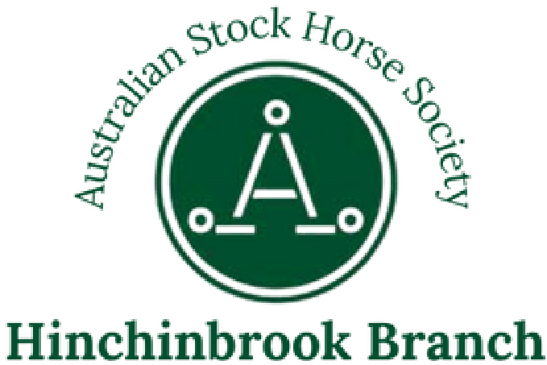**VIA Campdraft Central** Canteen & Bar Available all Weekend

Campdraft is open to ASH and Non-ASH Horses

ASH Affiliated, run in accordance with their General Information, Rules and Recommendations.

Each competitor is restricted to 8 first round runs each (excl. High Rollers)

Neither the organising committee nor The Australian Stock Horse Society Limited accept any liability for any accident, damage, injury or illness to horses, riders, beasts, ground, spectators, or any other person or property whatsoever.

All Competitors ride at their own risk

PIC# QHCS0456

Eftpos Available

No Powered Camping

Please be considerate with camp sizes

Horse Poo & Hay to be picked up and piled around trees or along tree line

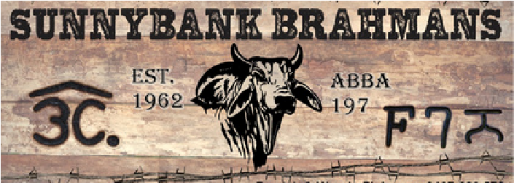**FRIDAY 29TH AUGUST** Highest Scoring ASH - Sponsored By: 9am Start

**HC Building & Construction - Encouragement Draft**

Straight out Contest

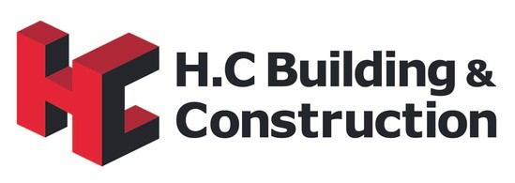Nomination $45 - $5 Add Back



Highest scoring

registered ASH in each

open age draft to

be awarded

(

Excl.. high rollers

)

$700 Prize Money, Pays out to 6th place

2 horse limit,

Competitor must be 17yrs or over

Competitor has not won or placed 3 times in an open aged event

Encouragement Award - Donated By: Dare to Dream Ropes

# BP Electrical & Refrigeration - Maiden Draft



Maiden Trophy Sponsored by:

1 Round + Final

Nomination $60 - Pays to 6th place

$1500 Prize Money - $10 add back

**Maiden Final**

# Friday Night - Live band & Auction

**SATURDAY 30TH AUGUST** Highest Scoring ASH - Sponsored By:

7am Start

# Northern Brahmans - Juvenile Draft

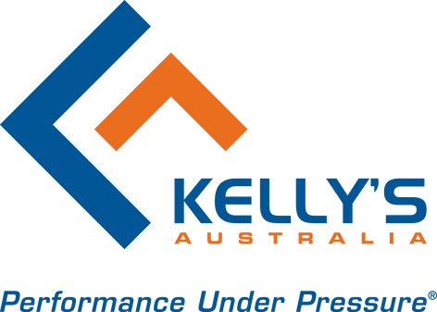

Highest scoring

registered ASH in each

open age draft to

be awarded

(

Excl.. high rollers

)

Straight Out Contest

Encouragement Award - Donated By:

$35 Nomination - $5 add back

$600 Prize Money - Pays to 6th place

Competitors Aged 13 - under 17yrs

2 horse limit

# Kellys Australia - Junior Draft

Straight Out Contest

$20 Nomination - $5 Add Back

$400 Prize Money - Pays to 6th place

Competitors Aged 8 - 13yrs, 2 horse limit Encouragement Award - Donated By:

# Nourish Banana Co / Cassowary Coast Earth Moving Tom Mauloni Memorial Open Draft

One Round + Final

$60 Nomination - $10 Add Back

$1500 Prize Money - Pays out to 6th place

# SATURDAY - CONTUNIED

**MC Rural Contracting - Mini Horsemanship**

5yrs - U8yrs

$5 Nomination

Restricted to 1 horse

On or off lead

Man Cow

**Tom Mauloni Memorial Open Draft**

**Final High Rollers**

Highest scoring

registered ASH in each

open age draft to

be awarded

(

Excl.. high rollers

)

50% 20% 10% 5%

$155 Nomination

Excluded from your 8 runs

Open to all horses

Winning will change horses competition status

## Saturday Night

Novelty Teams Bending Relay (2 riders per team)

Highest Scoring ASH - Sponsored By: Must be a nominated campdraft competitor to compete

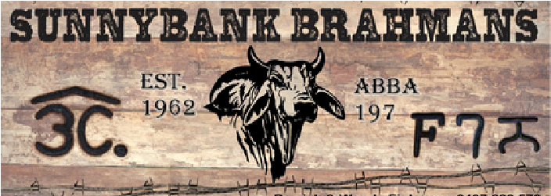(16yrs & Over)

$20 cash Nomination on the day

Dog High Jump Competition

# SUNDAY 31ST AUGUST

7am Start

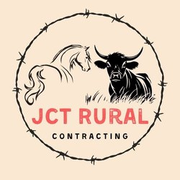**JCT Rural Contracting/Lamperds Pest Control**

**- Ladies Draft**

Straight Out Contest

$40 Nomination - $5 add back

$500 Prize Money - Pays out to 6th Place

Ladies who have not competed in any other draft over the weekend, except for the encouragement

ladies Trophy sponsored by: 2 horse limit

One Round & Final

Encouragement Award - Donated By:



**MAMS Cassowary Coast - Novice Draft**

$1500 Prize Mo

ney - Pays out to 6th place

Novice Trophy sponsored by:

Highest scoring

registered ASH in each

open age draft to

be awarded

(

Excl.. high rollers

)

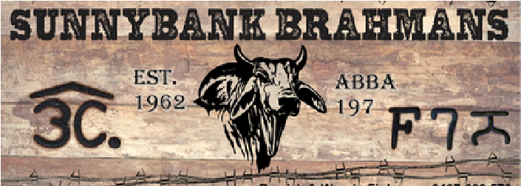

Highest Scoring ASH - Sponsored By:

$60 Nomination - $10 Add Back

 **Novice Final**

All competitors must be current ASH members

 Or Day Member - $50 per Adult, $20 Per Child

NO MEMBERSHIP NO RIDING

To register for highest scoring ASH in each open age draft please email through your horses ASH registered number.

The Committee reserves the right to alter, delete or amend the program without notice, anytime. Judges decision is FINAL

All stallions to be contained on the grounds as per CCA rule 11.12.

Under no circumstances are U17yrs permitted to ride/handle stallions within the perimeter of the grounds. All competitors compete at their own risk

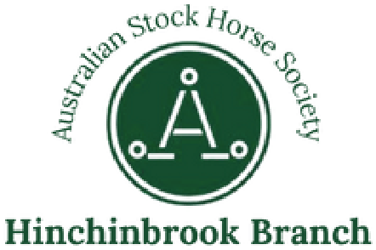All Nomination fees include stock levy & ambulance levy

Helmets: Riders under the age of 18 must wear helmets whilst mounted on a horse. Helmets must comply with current Australian and New Zealand safety standards and must be securely fastened under the chin at all times.

Committee reserve the right to retain any nomination fees if scratching’s are made 7 days prior to 7am of the first day of the program.

Scratching’s received 72hrs of 7am of the first day of the campdraft forfeit entire nomination fee, unless in extenuating circumstances.

ALL run changes are to be done 24hrs prior to the first day of the draft no exceptions unless in extenuating circumstances.

Enquiries: - Secretary Talena Young P: 0498498765 E: hinchinbrookASHS@gmail.com

Treasurer Claudia Copley P: 0457666764 E: copleys0019@gmail.com

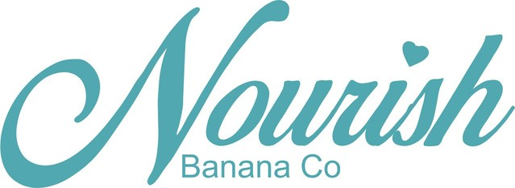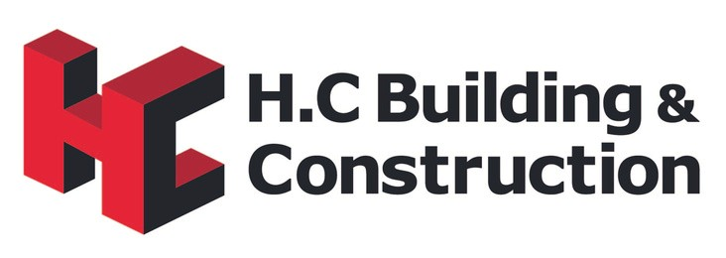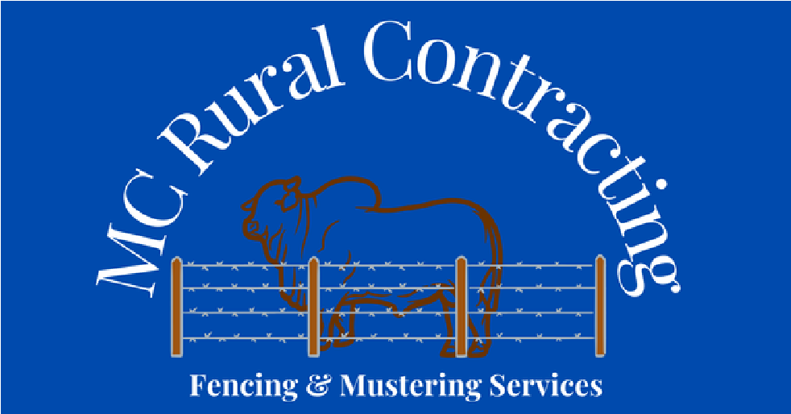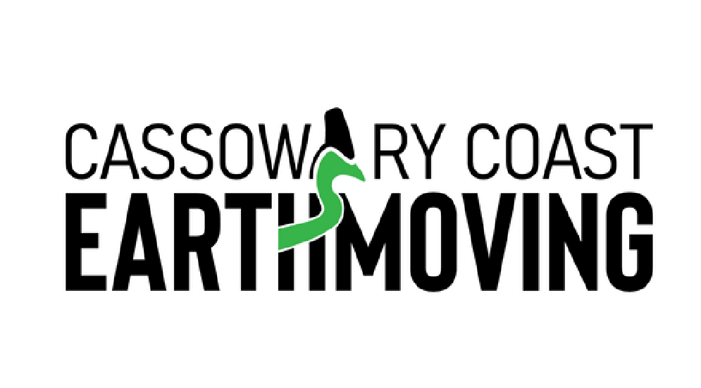

**SPONSORS 2025**

**THANK YOU!**