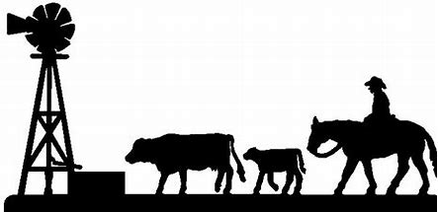
Mulgildie Saddle Cloth Campdraft
Proudly Sponsored by the
Sunday 3rd and Monday the 4th of May 2026
Mulgildie Sports Grounds- 1 Park Street, Mulgildie, QLD 4630
Start Time- 6:30am
Free Admission
PIC#QGMN0640
CCA Affiliated, draft is run in accordance with their General Information, Rules and Recommendations. All competitors MUST add the CCA Event fee of $10 when nominating. Nominations open Monday 13th of April 2026 at 6am for 24 hours via Campdraft Central. Payment due 25th of April 2024.
Winners of all drafts will receive an Embroidered Trophy Saddle Cloth from Monto Saddlery & Witchy Stitchy Embroidery
All nominations apart from the Junior and Mini include a stock levy.
Stock Levy - $20 add (subject to change due to fuel costs)
Canteen operating Saturday, Sunday & Monday with Dinner available Saturday and Sunday Nights. Breakfast from 5:30am
EFTPOS available but NO cash withdrawals
Free camping, showers & toilets available on grounds
Medical Services provided by QAS
Vet Services provided by Monto Veterinary Group (07) 4166 1285
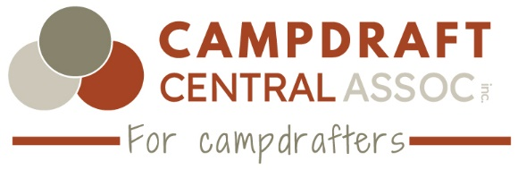

Sunday 3rd May- 6:30am Start
Order | Event | Nomination Fee
1-Open Draft | Albert Hotel Open Draft  $2000 Prize Money. 1st round prize money 1st to 4th. Final Round prize money 1st to 8th place. Cut out trophy first round only. | $70
2-Junior Draft | DJ Steel & Concrete Monto Junior Draft  $150 Prize Money. Prize Money to 5th place. 8 to Under 13 years. One horse per rider | $10
3-Juvenile Draft | Monto Veterinary Group Juvenile Draft  $200 Prize Money. Prize Money to 6th place. 13 to Under 17 Years. Cut out Trophy. | $20
4-Mini Draft | Skin Brian’s Mini Draft  $50 Prize Money. 5 to Under 8 Years. 1st to 4th prize money. Must be riding independently off the lead to compete. One horse per rider. To be run in the rodeo arena at the completion of the Junior Draft. 1 horse per rider. | $5
5-Novice Draft | Rodelle Performance Horses Novice Draft  $1600 Prize Money. 1st round prize money 1st to 4th. Final Round prize money 1st to 8th place. Cut out trophy first round. | $60
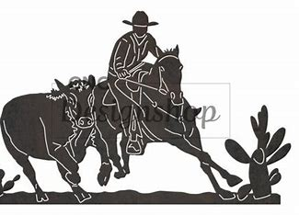
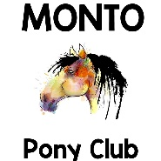

Pony Club Horse Events
Kindly Sponsored by Accounting and You Monto
Run at the completion of the Juvenile Draft. Nomination via Campdraft Central All competitors MUST add the CCA Event fee of $10 when nominating
Entry fee- $15.00 (5 events)
Events include- Flag Race, Western Bend, Stockhorse Race, Diamond Flag, Sporting Figure of 8
Age Groups- 5 and Under 7yrs, 7 and Under 9yrs, 9yrs and Under 11yrs, 11yrs and Under 13yrs & 13yrs and Under 17.
All events will be timed. Ribbons for each event. One horse per rider.
Prize Money- 1st $20, 2nd $15, 3rd $10 for each overall age group placegetter.

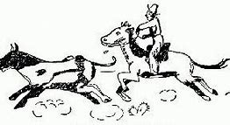
Highest Cut-Out Competition
Kindy Sponsored by Sunwater
$20 Nomination Fee- 1 Horse per rider. First 20 nomination (there is a 24hr period for nominating period) $300 Prize Money! Winner takes all! Under lights after the completion of the 1st round of the Novice Draft.

Monday 4th May- 7am Start
Order | Event | Nomination Fee
6-Encouragement Draft | KellCo Monto Encouragement Draft  $500 Prize Money. Encouragement Rider, a rider 17 years and over. Has not won an Open age draft (i.e. Maiden, Novice, Open, Ladies, Associates) or a restricted draft. A win will not alter the status of the horse. Competitors cease to be eligible to compete after winning one (1) Encouragement, or one (1) open age campdraft, or placing three (3) times in open age campdraft. | $35
7- Oldies Draft | Bryson Head MP Oldies Draft  $300 Prize Money. Prize money to 4th. Cut out trophy first round. Over 55 Event. 1 horse per rider | $35
8- Maiden Draft | Roundyard Biloela Maiden Draft  $1000 Prize Money. 1st round prize money 1st to 4th. Final Round prize money 1st to 8th place. Cut out trophy first round. | $50
10- Novice Final | Rodelle Performance Horses Novice Final  1st to 8th Place Prize Money.
9- Maiden Final | Roundyard Biloela Maiden Final Draft  1st to 8th Place Prize Money.
11- Open Final | Albert Hotel Open Final Draft  1st to 8th Place Prize Money

Nominations open Monday at 6am 7th of April 2026 for 24 hours via Campdraft Central. Payment due 22nd of April 2026.
Mulgildie draft is run under Campdraft Central Association Inc. rules and guidelines.
Scratching’s $20 stock levy to be retained if cancellations are not scratched prior to 26th of April 2026 8am 7 days from the commencement of the draft. Late scratching’s after this date will not be refunded unless extenuating circumstances.
The committee reserves the right to alter, amend or cancel any event.
Judge’s decision is final in all cases.
All riders under 18yrs MUST wear an approved helmet while riding on the grounds (refer to rule 19 of CCA rules and guidelines)
Prize monies paid as per CCA General Rules & Guidelines 24
Any competitor who in the opinion of the Executive Committee deliberately mistreats or abuses livestock will be disqualified from the event and from participating in any further events on the program. No refund of nominations will be offered.
All dogs must be always kept on a leash or be kept securely tied up while on the grounds.
Disclaimer- The Mulgildie Campdraft and Rodeo Association does not accept any liability for any accident, damage, injury or illness to any competitors, horse, spectators or other person or property whatsoever.

Cassie Worley
mulgildiecdandra@gmail.com
0401914731
Secretary

